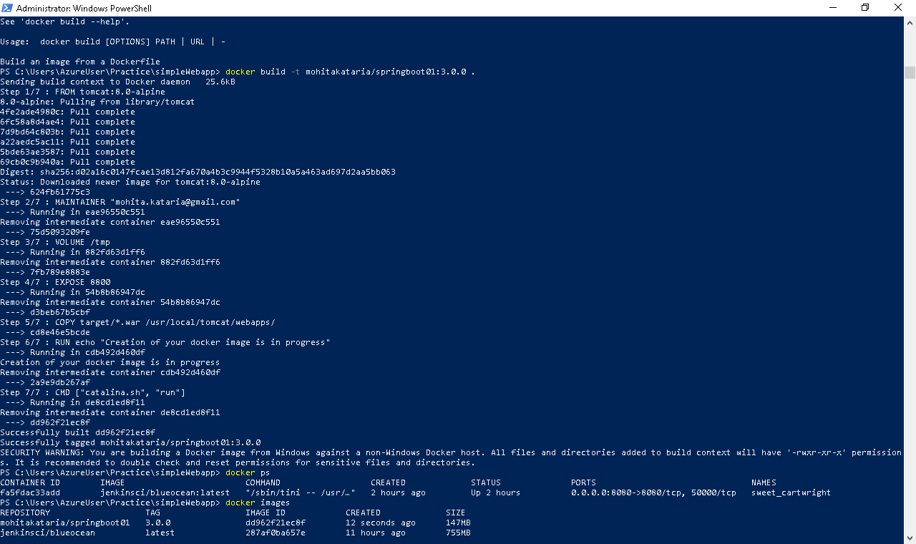

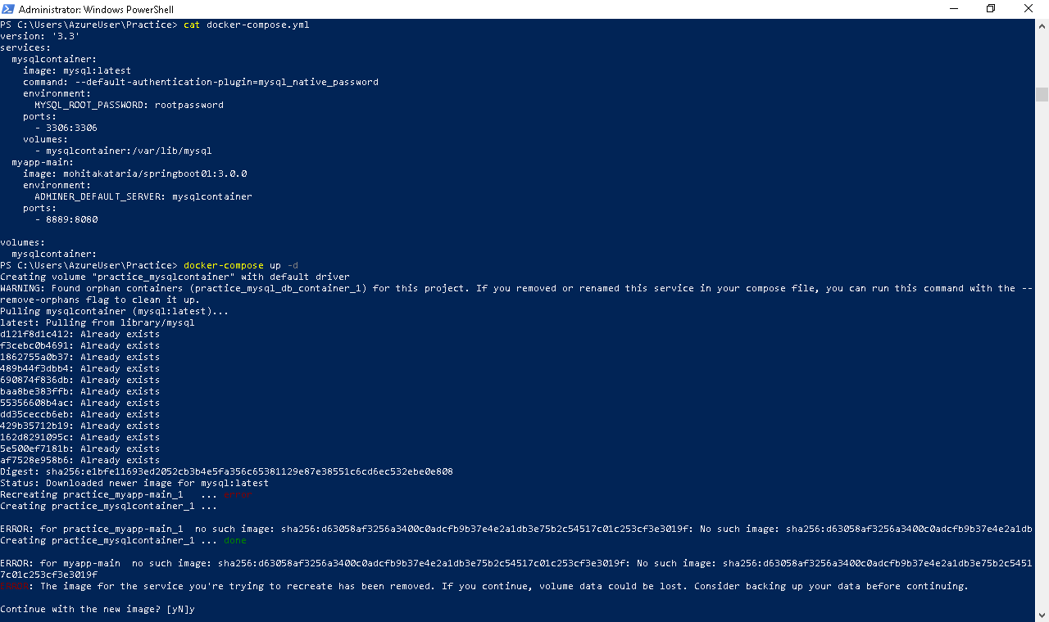

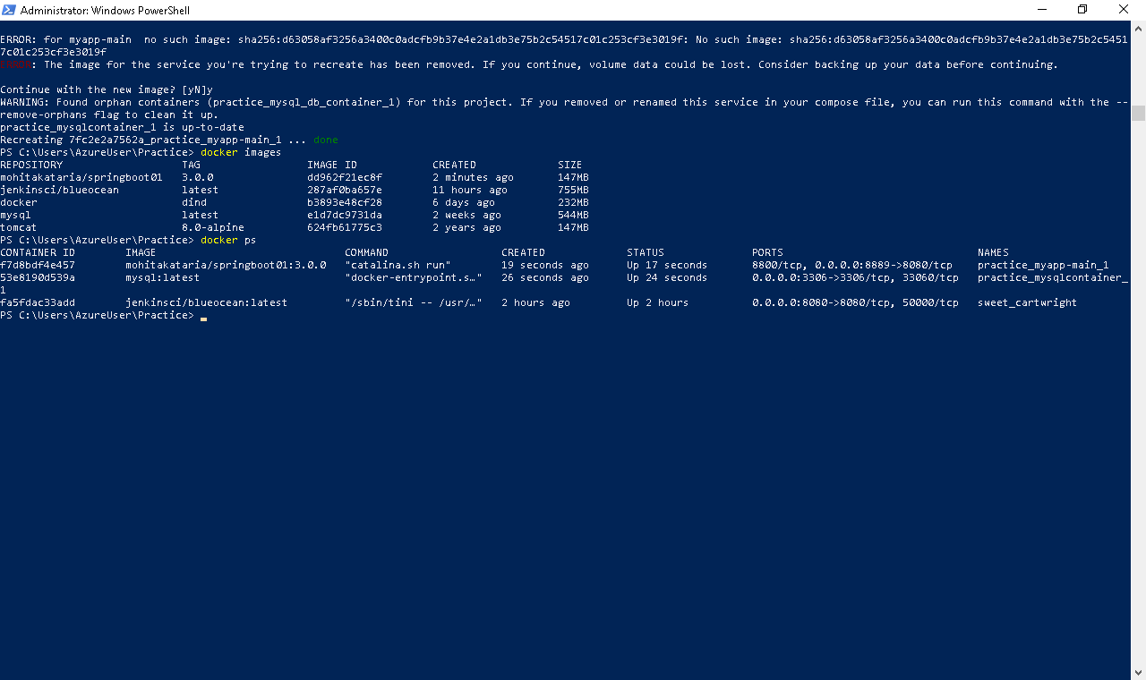

Docker-compose:

version: '3.3'

services:

mysqlcontainer:

image: mysql:latest

command: --default-authentication-plugin=mysql_native_password

environment:

MYSQL_ROOT_PASSWORD: rootpassword

ports:

- 3306:3306

volumes:

- mysqlcontainer:/var/lib/mysql

myapp-main:

image: mohitakataria/springboot01:3.0.0

environment:

ADMINER_DEFAULT_SERVER: mysqlcontainer

ports:

- 8889:8080

volumes:

mysqlcontainer: